Phase 1 PM Onboarding: Work Summary
Chahat Beniwal · Junior Product Manager · Prepared for mentor review · 7–25 September 2026
I joined straight after graduation and am working through Phase 1: Foundations, a structured onboarding plan of 9 modules and 76 tasks (225 estimated hours). It teaches three things together: working out what's worth building (discovery), getting it built (delivery), and working fluently with Claude (Chat, Cowork, Claude Design). Every task ends in an artefact I made, and I keep a daily journal where Claude asks me one sharp question about whatever confused me.
Much of the practice uses fictional client briefs that deliberately leave information out: PawPal (a pet-sitting app whose main problem is trust), Harvest Hub (an admin tool for a produce distributor) and ClaimLens (AI claims triage, for the final capstone).
38 / 76  tasks complete | 5 of 9  modules finished | ~91 hrs  logged (104 est. hrs done) | ~30  reusable prompts
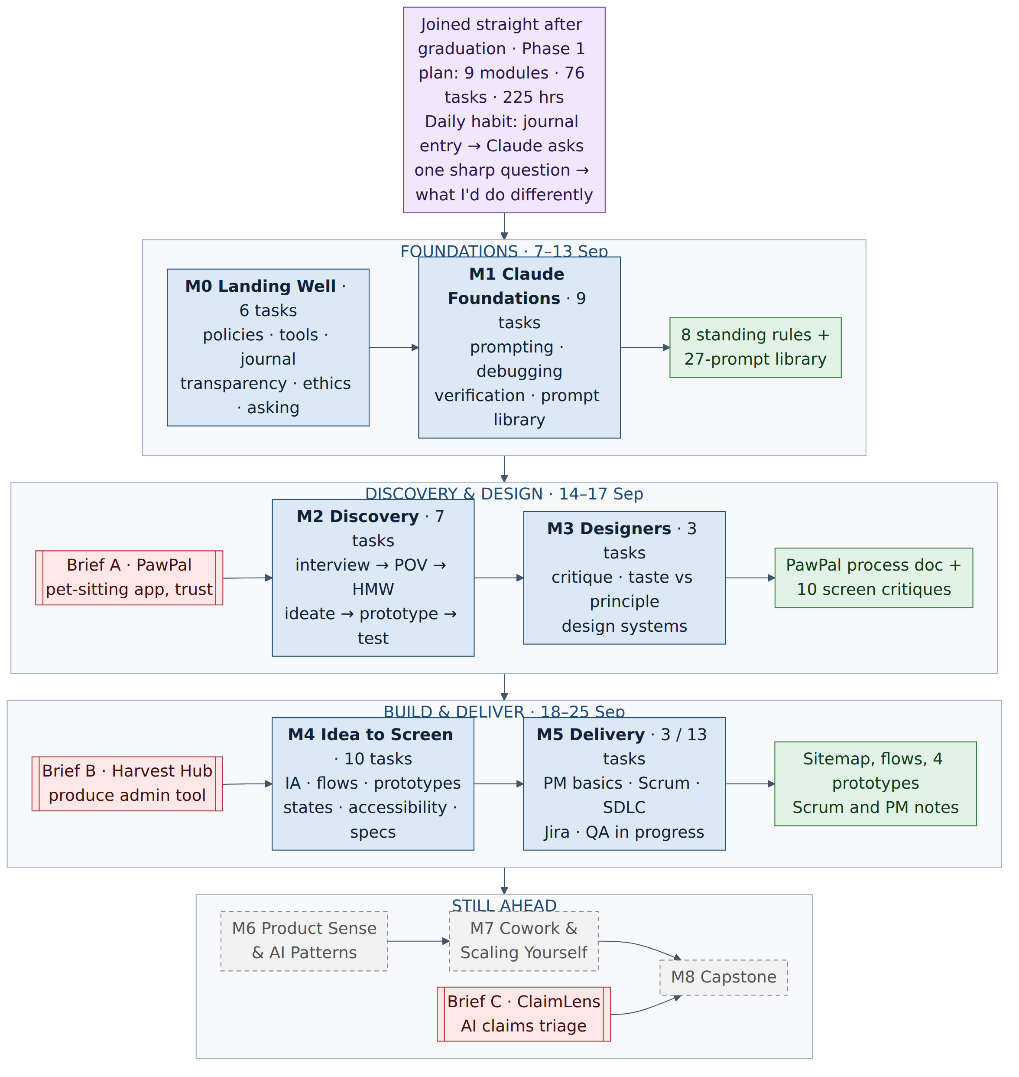
Step | Output / artefact | Decision / check | Learning | Brief | Not done yet
Each of the next six pages covers one module: why it exists, how I worked, what I produced, a detailed flowchart of the actual steps and decisions, and what I learned.
Module 0 · Landing Well
6 tasks · complete · 7–9 Sep · how this workplace works
WHY  At university the rules were written down; at work they usually aren't. This module makes the unwritten parts explicit before any product work begins. | HOW  I read the policies twice, took my questions to my mentor, practised transparency and ethics on real examples, and had Claude critique each draft. | WHAT I PRODUCED  Answers to five policy situations, the learning journal, before-and-after messages, a dark-pattern redesign, the 30-minute rule and a blocker template.
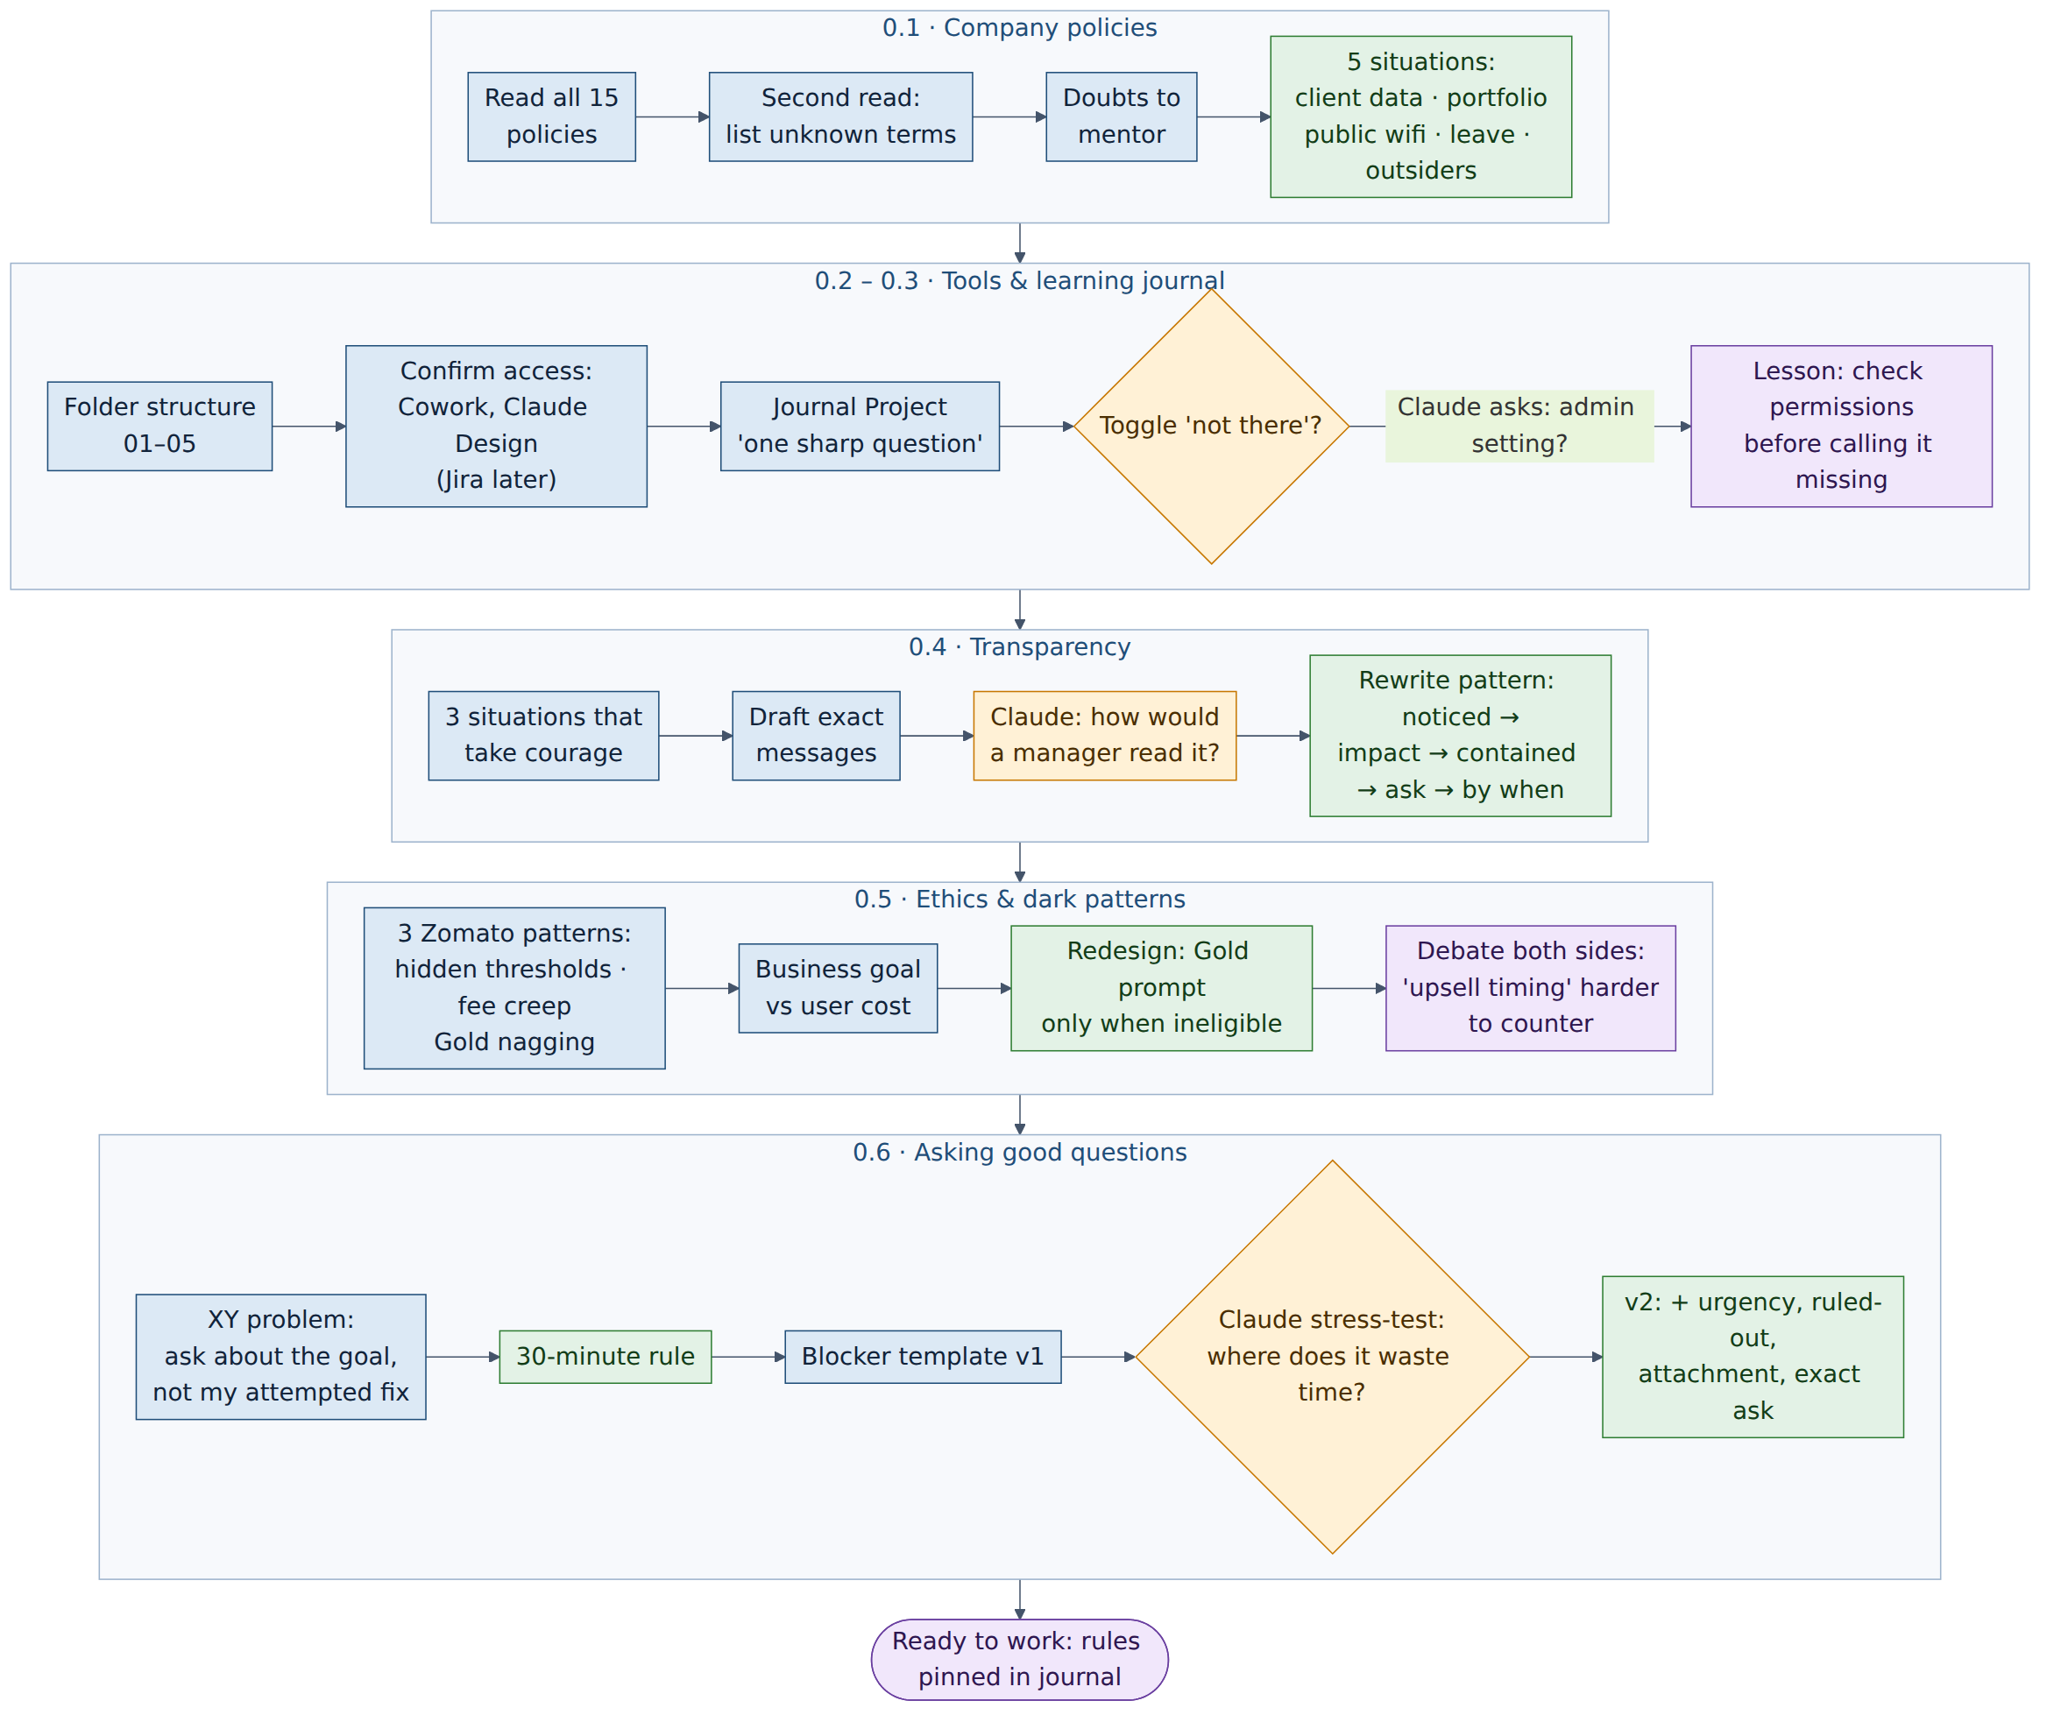
What I learned
- Check permissions before calling a feature missing. My first journal entry claimed a setting didn't exist; it was an admin control I couldn't see.
- Share early, and be specific. Messages that take courage follow one pattern: what I noticed → its impact → what I've already done → a specific ask → by when.
- Persuasion vs manipulation. A Gold-membership upsell shown to people who already get free delivery manufactures a feeling of loss. The honest version shows it only when they're actually ineligible.
- Ask about the goal, not the fix I tried (the XY problem). The blocker template makes me state what I'm trying to achieve and what I've already ruled out.
Module 1 · Claude Foundations
9 tasks · complete · 9–13 Sep · getting reliable work from AI, and knowing when not to trust it
WHY  Everything later in the plan runs on Claude, so I needed a mental model of how it works, a repeatable way to prompt it, and the habit of checking what it says. | HOW  I explained each concept to Claude and let it correct me, compared prompt versions side by side, debugged by changing one thing at a time, and checked claims against primary sources. | WHAT I PRODUCED  A prompt skeleton, annotated prompt comparisons, a five-round debugging log, a capability cheat sheet, three configured Projects, a verification rule and a 27-entry prompt library.
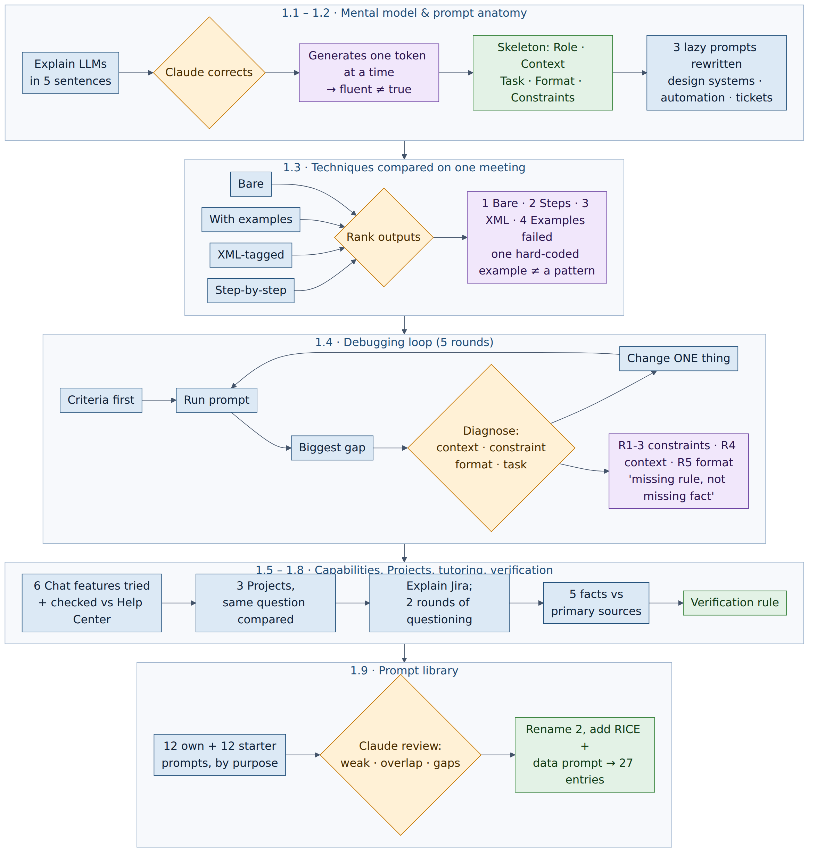
What I learned
- AI writes one token at a time, so how fluent it sounds is no guide to whether it's true. Hence the rule: always verify numbers, dates, names, citations, and medical or industry claims.
- Structure beats length. Role · Context · Task · Format · Constraints fixed audience, focus, structure, length and tone. The lazy 'tickets' prompt even answered the wrong question.
- More technique isn't better. The plain prompt ranked first; a single hard-coded example failed because examples need to show a pattern.
- Debug one variable at a time. Most fixes were missing rules rather than missing facts, and judging criteria must be written before reading the output.
Module 2 · Discovery and Problem Definition
7 tasks · complete · 14–16 Sep · Brief A: PawPal
WHY  Products start with a person's problem, which clients describe imperfectly. This module teaches the design-thinking loop for turning a vague brief into a problem a team can build against. | HOW  I ran all five stages on PawPal: a real interview, clustering, a point-of-view statement and How Might We questions, ideation with Claude, a fidelity choice, and a usability test with a colleague. | WHAT I PRODUCED  An interview guide and findings, a final POV and five HMW questions, three solution directions, a fidelity rule, a test script and wireframe, and the full PawPal process write-up.
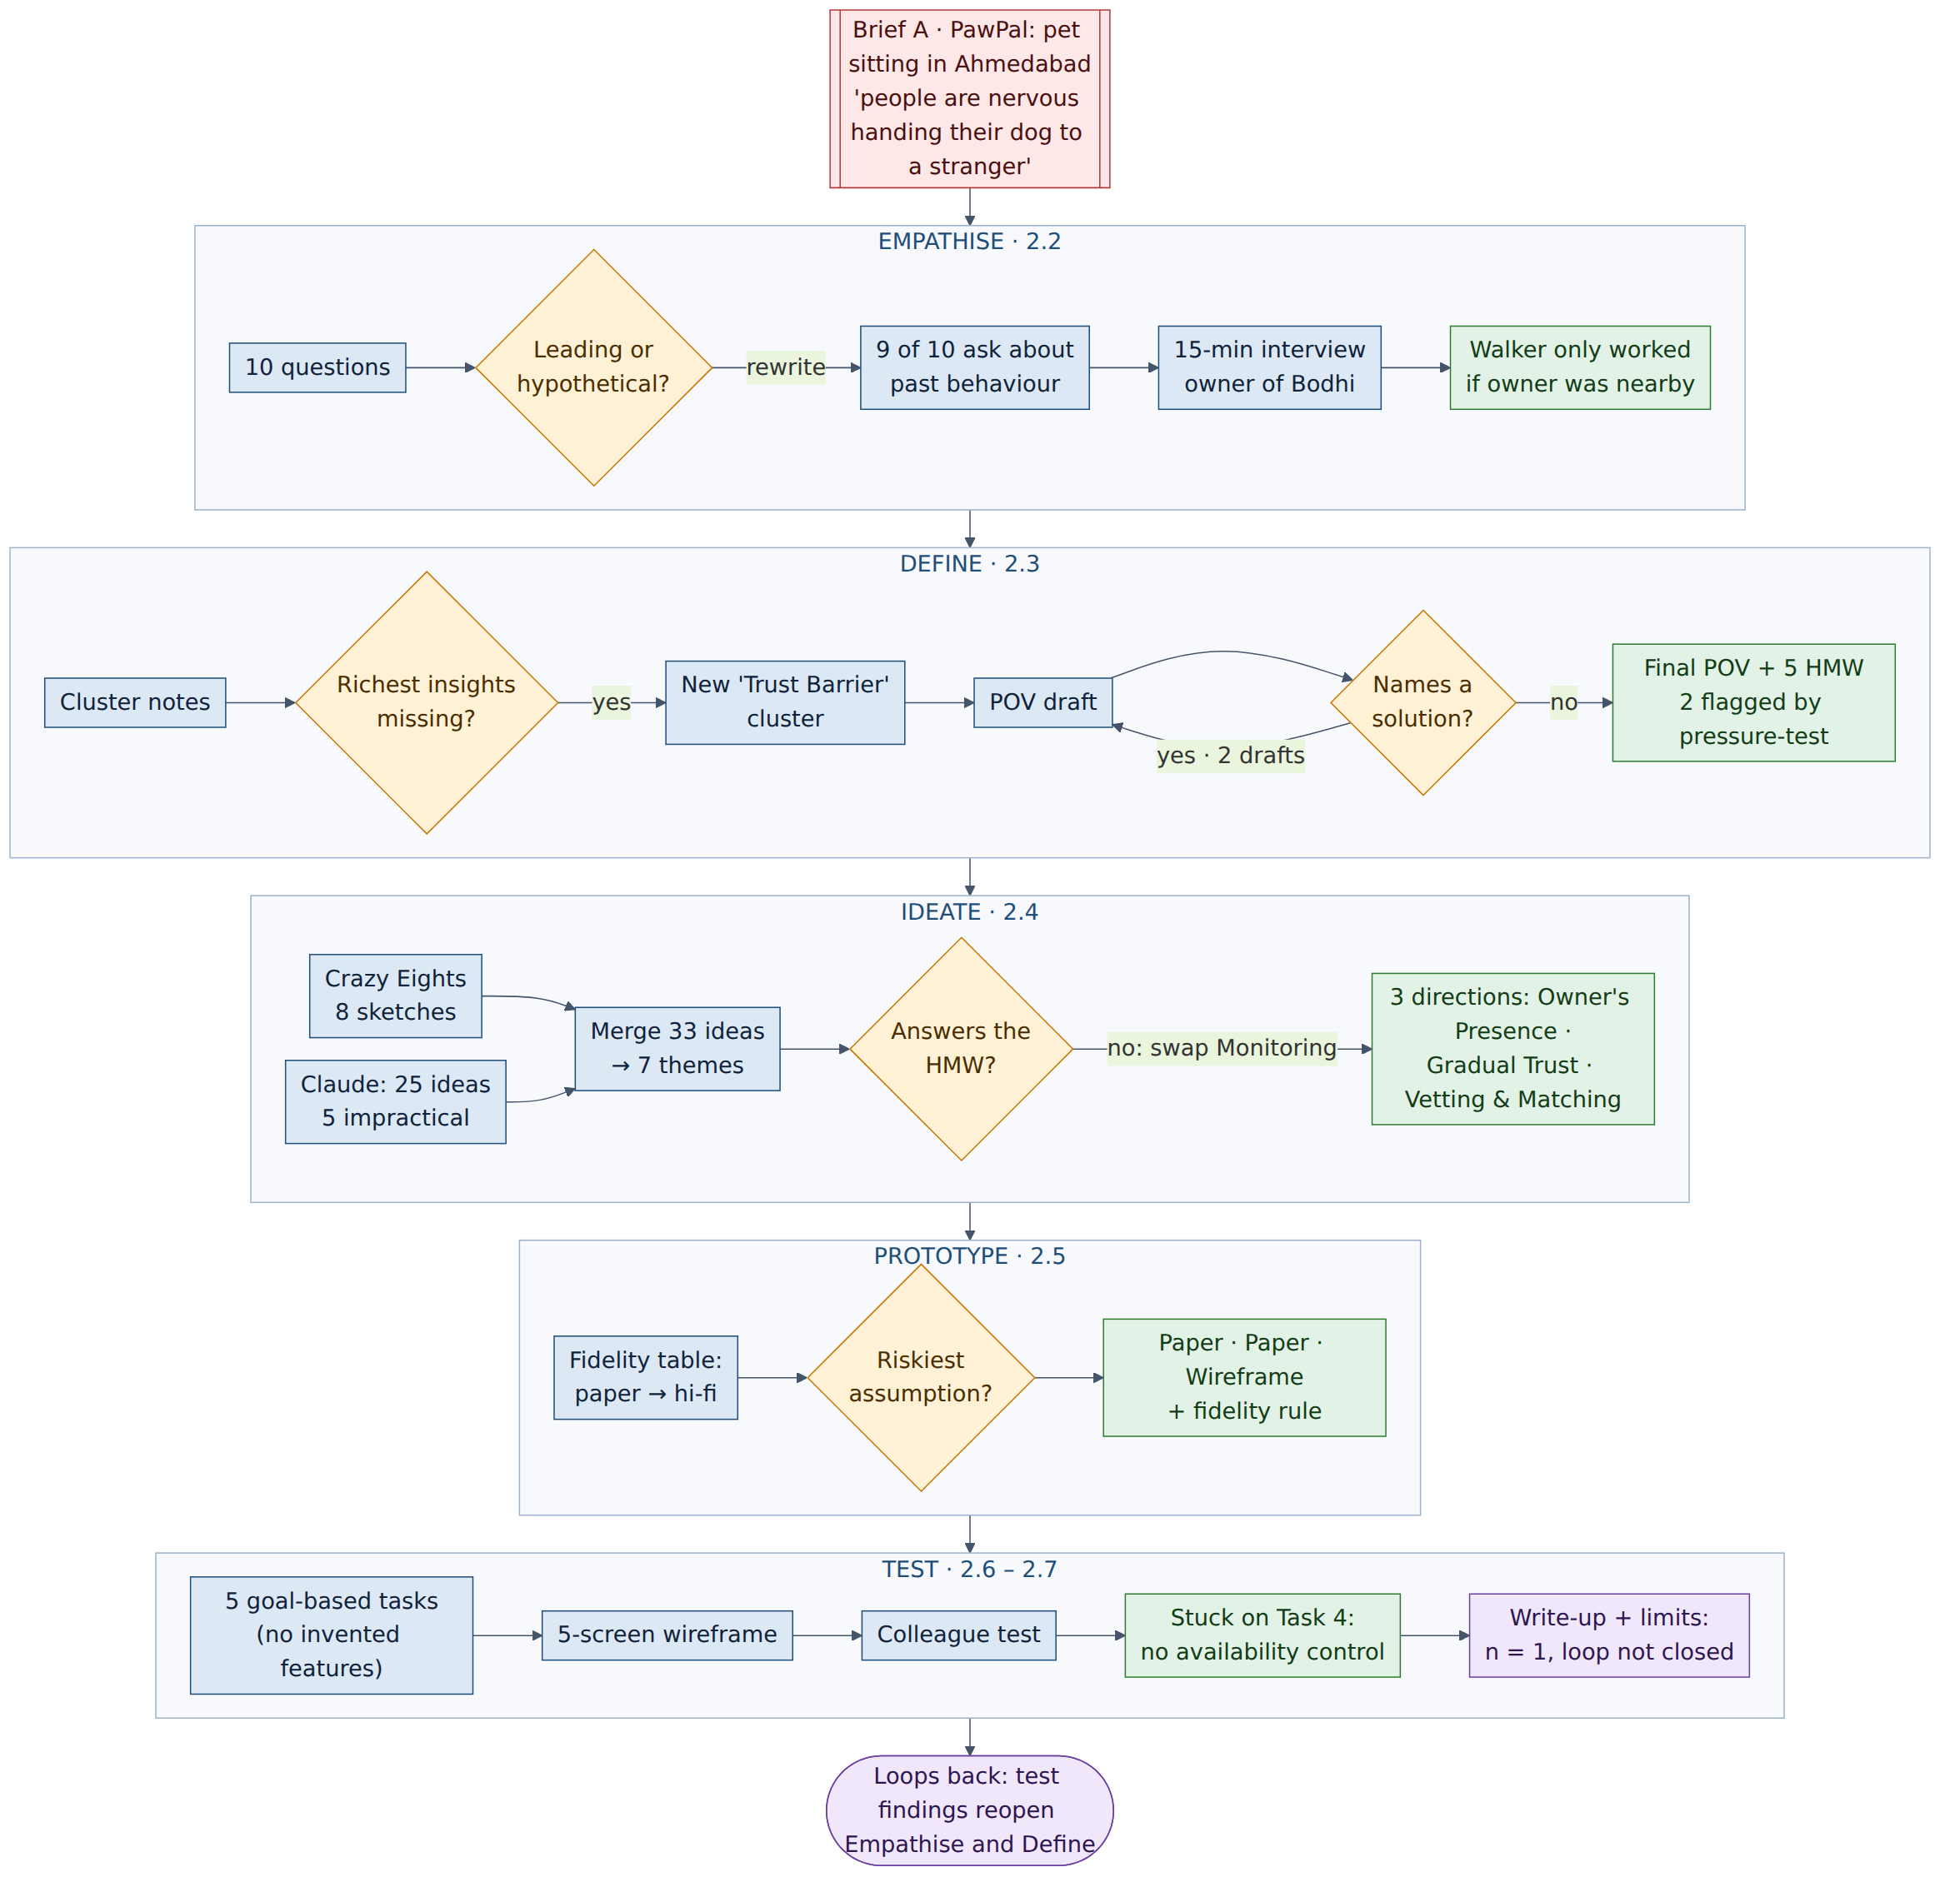
What I learned
- Vetting and payment don't transfer trust. Even a paid walker only worked when the owner stayed nearby. That single insight shaped everything downstream.
- The process catches what instinct misses. It surfaced the insights my first clustering dropped and the POV drafts that named a solution instead of the need.
- Claude is most useful at choosing, not generating. Checking each idea against the HMW question removed a direction that sounded good but didn't answer it.
- Following my own spec literally isn't judgment, and n = 1 isn't a pattern. Ratings and reviews never reached the wireframe, and the write-up states its limits honestly.
Module 3 · Working with Designers
3 tasks · complete · 15–17 Sep · visual literacy, critique and design systems
WHY  As a PM I brief and review rather than design. 'I don't like it' wastes a designer's time; feedback tied to a principle gives them something to act on. | HOW  I adopted five screen checks, critiqued a deliberately bad page, a real login page and ten app screens, then compared Material 3 with Apple's guidelines. | WHAT I PRODUCED  Structured critiques checked for where I stated preference as principle, a rule to stop that happening, and notes on what a design system buys a team.
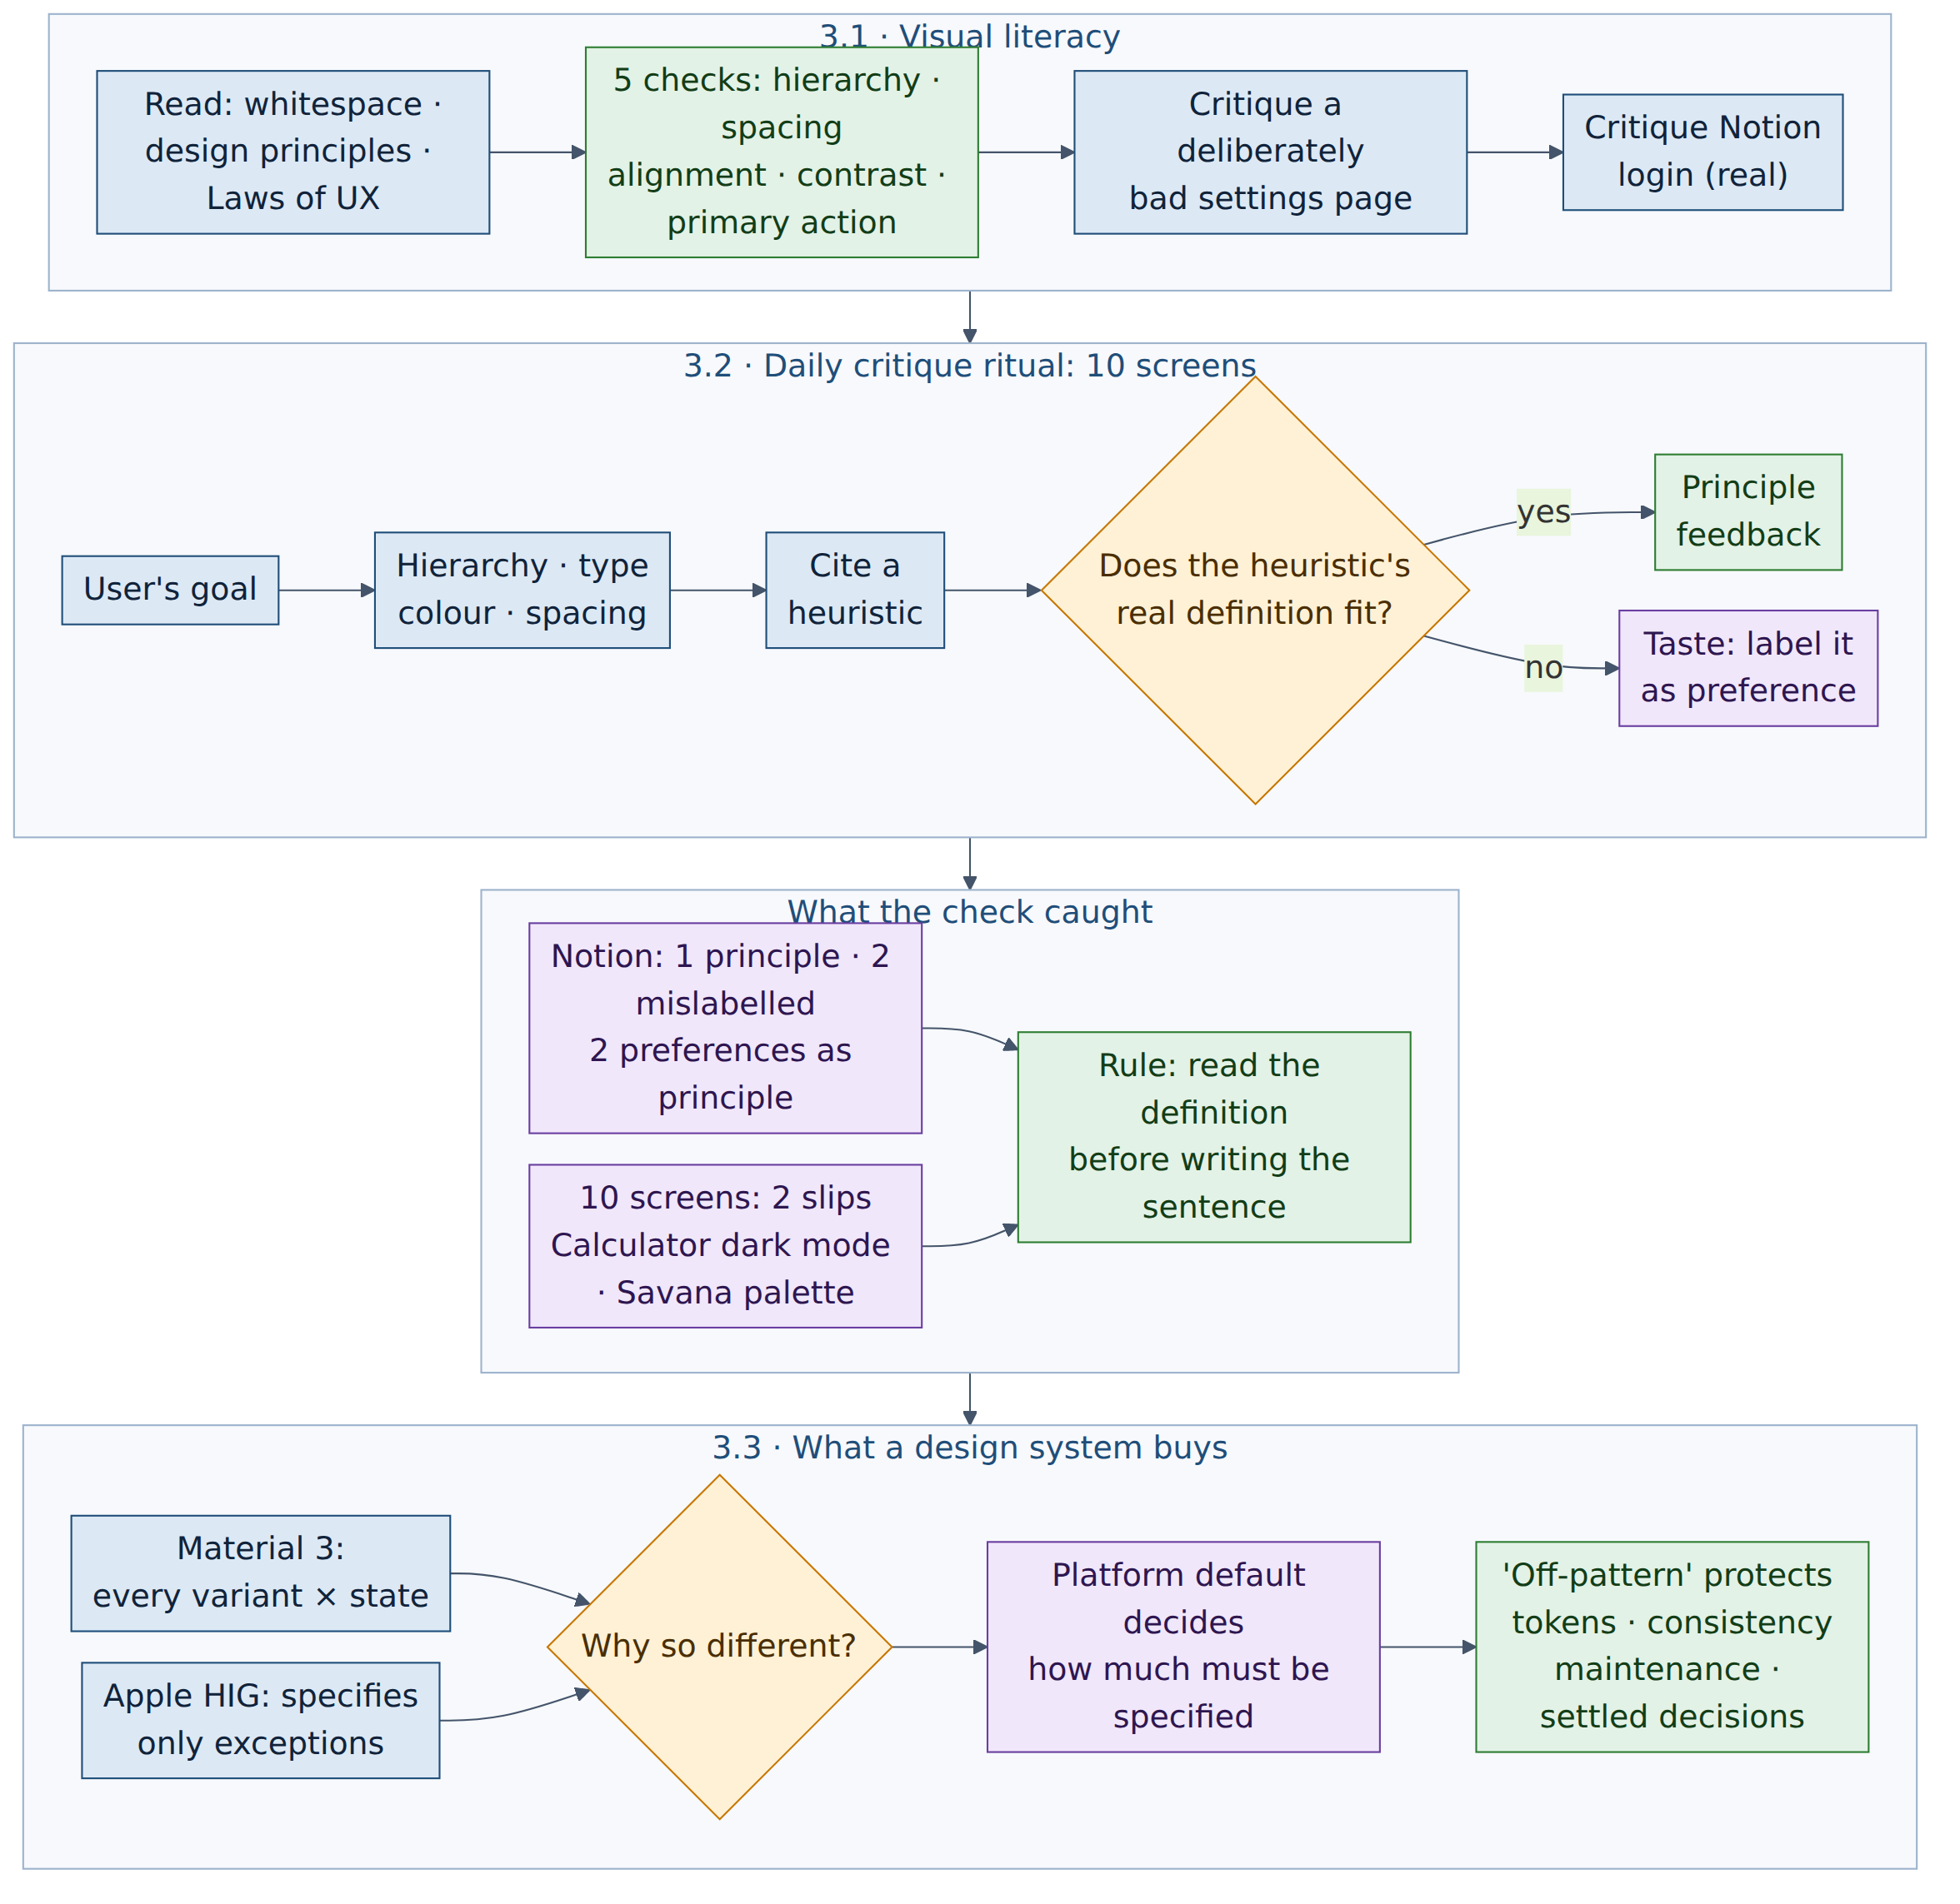
What I learned
- Hierarchy vs alignment: centring everything on a page is consistent alignment, not a violation. Knowing the exact term makes feedback actionable.
- Taste sneaks in when the format demands a heuristic and my observation doesn't fit one. The fix is to read the definition first.
- Design systems: Material specifies every button variant in every state because it has no default look; Apple only specifies exceptions. Departing from a system costs exactly what it was buying you.
- 'Off-pattern' protects tokens, consistency, maintenance and settled decisions. Push back only with evidence of a real user need, or when you're willing to own the trade-off.
Module 4 · From Idea to Screen
10 tasks · complete · 18–23 Sep · Brief B: Harvest Hub (plus PawPal for 4.10)
WHY  This is where requirements become something people can click. A PM has to structure information, talk credibly with engineers, and specify screens precisely enough to build. | HOW  I built the structure first (inventory, sitemap, flow), then prototypes in Claude Design, iterated in logged rounds, audited states and accessibility, and read the generated code to confirm the fixes. | WHAT I PRODUCED  A role-based sitemap, the order-to-delivery flow, Settings and Order Management prototypes, 8 designed states, an accessibility-fixed build, and a three-version precise spec.
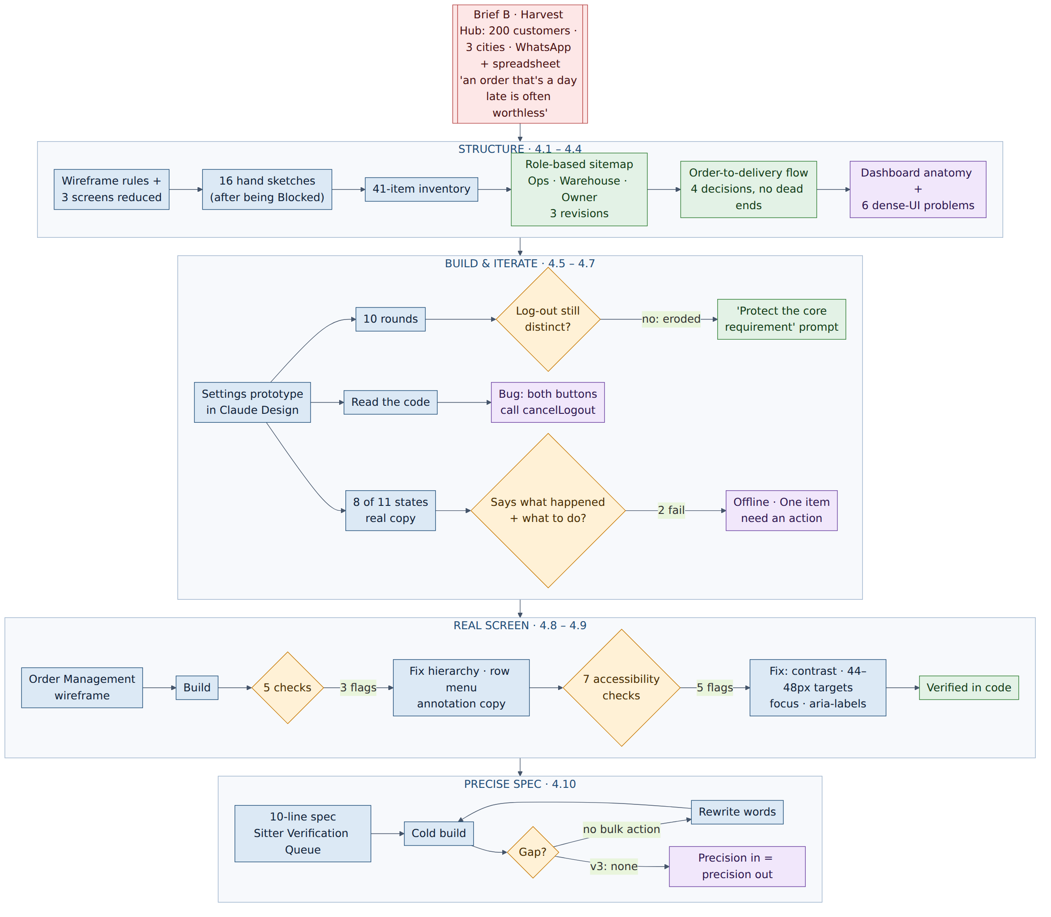
What I learned
- Organise by the user's logic, not the system's. Driver workload moved next to the reassign decision it informs.
- Requirements erode quietly across rounds, so I restate the one that must survive and check it every round. Code can hide bugs too: the Log-out confirm button never actually logged out.
- Unhappy paths are part of the spec. Error copy must say what happened and what to do next. Accessibility (contrast, target size, focus, labels) is decided at design time.
- Precision in, precision out. A requirement that isn't in the spec's actual words doesn't get built; each rewrite changed exactly what its words changed.
Module 5 · Delivery (in progress)
3 of 13 tasks · 23–25 Sep · the operational core of the job
WHY  Shipping depends on planning, sprints and working with engineering and QA. A PM has to know where their effort matters in each ceremony and phase. | HOW  I defined the core project-management terms, mapped every Scrum ceremony with its purpose, attendees and time-box, drew the software lifecycle, and asked Claude what a PM actually does in each. | WHAT I PRODUCED  Notes on the iron triangle and key terms, a Scrum ceremony and role map, an SDLC comparison, and a Jira sandbox set up ready for the Harvest Hub board.
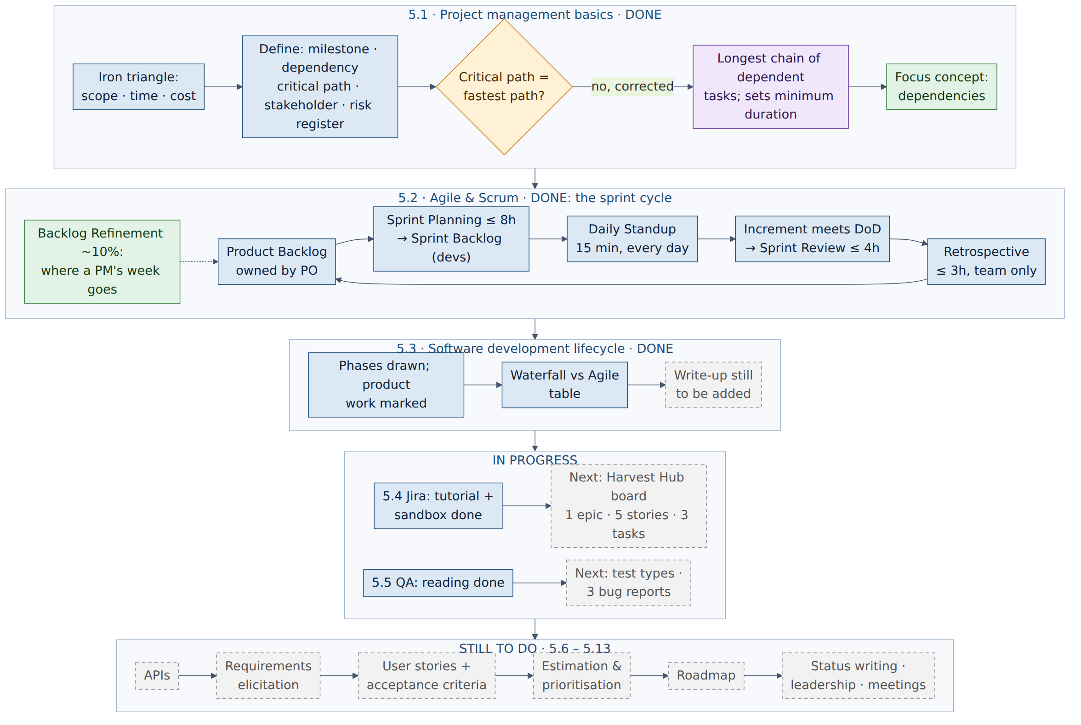
What I learned
- Critical path is the longest chain of dependent tasks, and it sets the minimum project duration. My first definition had it backwards as the fastest path.
- Dependencies are the concept I expect to matter most: chase the upstream blocker before a green status quietly turns red.
- A PM's week is mostly backlog refinement: sharpening acceptance criteria, splitting oversized items, cutting stale ones.
- Next: a Harvest Hub Jira board, bug reports against my prototype, then APIs, user stories, estimation and a roadmap.

